BALLIVOR HORSE SHOW - IPS SCHEDULE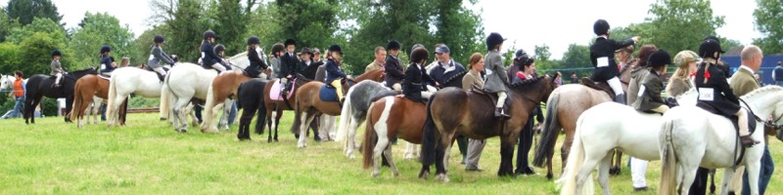
SATURDAY 13th JUNE 2026
RING 1 – start time approx 10.30am
Class 1 Show Hunter 153cms, ponies 4 yrs and over, not exceeding 153cms, riders under 20 years on 01/01/2026
Class 2 Show hunter 143cms, ponies 4 yrs and under, not exceeding 143cms, riders under 17 yrs on 01/01/2026
Class 3 Show Hunter 133cms, ponies 4 yrs and over, not exceeding 133cms, riders under 14yrs on 01/01/2026
Class 4 Ridden Starter Stakes, ponies 4 yrs and over, not exceeding 133cms, riders under 12yrs on 01/01/2026
SHOW HUNTER CHAMPIONSHIP; 1st & 2nd prize winners classes 1 - 4
Class 5 Lead Rein; ponies 4 yrs and over, not exceeding 123cms, riders under 8 yrs on 01/01/2026
Class 6 First Ridden, ponies 4 yrs and over, not exceeding 123cms, riders under 10 yrs on 01/01/2026
Class 7 First Year, First ridden, ponies 4yrs and over, not exceeding 123cms, riders under 9 yrs on 01/01/2026
Class 8 Hunter Pony Lead Rein, ponies 4 yrs and over, not exceeding 123cms, riders under 8 yrs on 01/01/2026
Class 9 Pure bred Welsh Lead rein, not exceeding 123cms, riders under 8 years on 01/01/2026
MINI CHAMPIONSHIP to include 1st & 2nd Prize winners Classes 5 - 9
Class 10 Mountain & Moorland; Ridden class for mare/geldings 4 yrs and over, mixed height from 123cms but not exceeding 148cms, riders any age

Ring 2 WORKING HUNTER PONIES
Approx start 10 am
Class 11 133cms Working Hunter, ponies 4yrs and over, not exceeding 133cms, riders under 14yrs on 01/01/2026
Class 12 143cms Working Hunter, ponies 4 yrs and over, not exceeding 143cms, riders under 17yrs on 01/01/2026
Class 13 153cms Working Hunter, ponies4 yrs and over, nor exceeding 153cms, riders under 20yrs on 01/01/2026

WORKING HUNTER CHAMPIONSHIP – 1st & 2nd prize winner Classes 11 – 13
SUPREME CHAMPIONSHIP
QUALIFIER FOR THE All-IRELAND PONY SUPREME CHAMPIONSHIP FINAL AT KILLUSTY PONY SHOW JULY 4th 2026
Class 14 Working Starter Stakes, ponies 4 yrs and over, not exceeding 133cms, riders under 12yrs on 01/01/2026
Class 15 Cradle Stakes, ponies 4 yrs and over, not exceeding 123cms, riders under 11yrs on 01/01/22026
Class 16 Working Hunter Lead Rein, ponies 4 yrs and over, not exceeding 123cms, riders under 8yrs on 01/01/2026. Riders will be asked to negotiate a small course of obstacles not higher than 12” in height

RING 3 – START TIME TBC
Class 17 In Hand Rescue pony, any height – PONIES MUST BE LED BY PERSONS OVER 16 YRS OF AGE
Class 18 Ridden Rescue pony, any height – riders any age
Class 19 NEW CLASS Veteran pony – 14 – 20yrs of age, ponies any height, ridden or lead rein
Class 20 Local Riding Class – children under 16yrs on 01/01/2026, ponies any height
Class 21 Local Lead Rein – children under 11yrs on 01/01/2026, ponies any height, to be led - PONIES MUST BE LED BY PERSONS OVER THE AGE OF 16YRS
Class 22 Fancy Dress – ponies and riders any age, any height
N.B Local classes are judged on the riders’ ability only, entries confined to residents within 20 miles of the showgrounds. Ponies that have previously won a Class at Ballivor Horse Show 2026 are not permitted.
ENTRIES AND ENQUIRIES TO: Rosaleen Barry 087/2626444 Helen Lynch 087/6920072 – helannlync@gmail.com
Entries can be made through: Its Plain Sailing or on the day, CASH ONLY

PLEASE NOTE THAT THE ORGANISERS RESERVE THE RIGHT TO, IF INSUFFICIENT ENTRIES ARE RECEIVED, CLASSES MAY BE ALMAGAMATED AND PRIZE MONEY ADJUSTED ACCORDINGLY

